**Step 1:- To View IP Address of guvi.in**

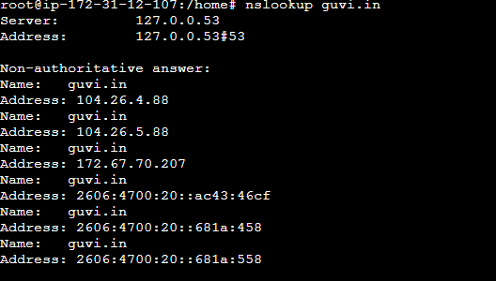

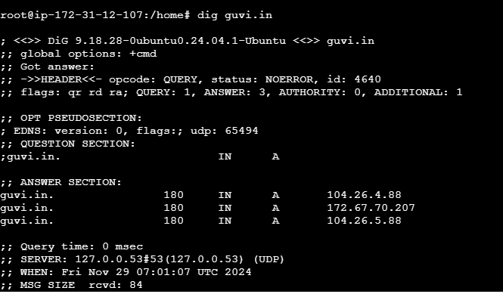

**Step 2:- To view the CPU/memory usage of my server**

**Command: - top**

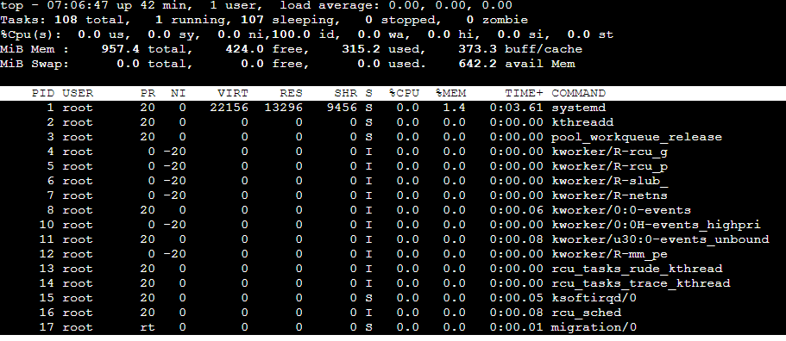

**Or**

**Command: - htop**

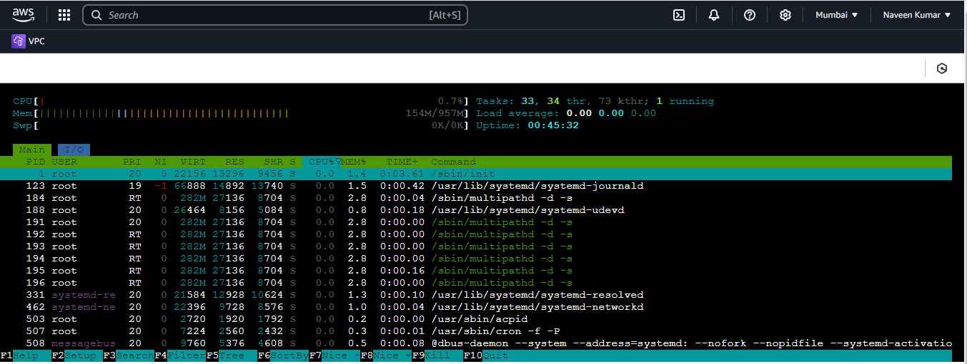

**Step 3:- Testing the connection between two nodes**

**Command: - ping guvi.in**

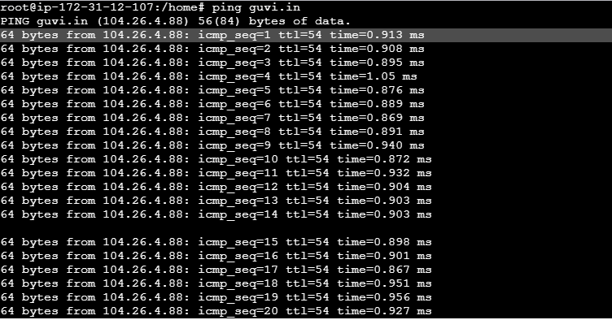

**Or**

**Command:- traceroute guvi.in**

We need install the traceroute as it will not available by default command to install traceroute command in the Linux machine is

**Sudo apt update**

**sudo apt install traceroute**

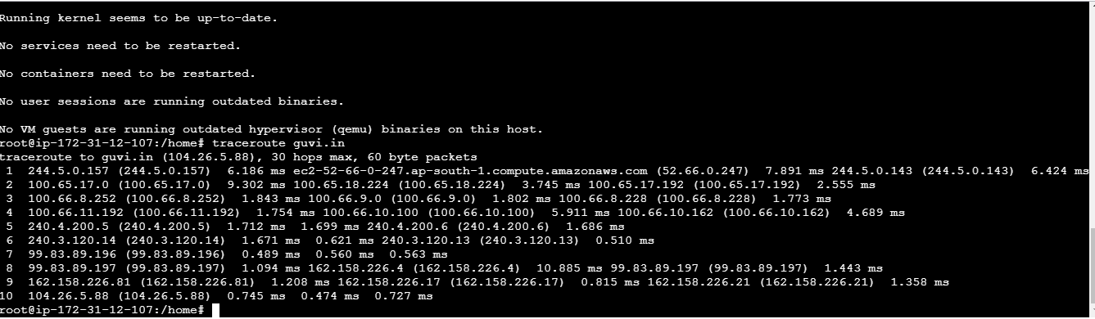

**Step 4:- Checking the whether my port is open or not**

**Command :- sudo netstat -tuln | grep :9000**